HILLTOP PRoperty IMProvement (PRIMP) Program
2018 Application Form (revised 9-11-2018)
Project Address:________________________________________________ Parcel #_______________
Applicant Name:______________________________________ Deed holder_____________________
Mailing Address: _____________________________________________________________________
Business Telephone: _________________________ Home Telephone: _____________________
Email: _____________________________________
Do you own or rent the project property? Own ---------- Rent ----------
If renting, landlord needs to sign below acknowledging PRIMP application permission.
Signature: __________________________________________________________________________
In the space below or on an attachment, please specifically describe your project. Plans must include an itemized list of estimated costs and contractors’ bids for the work. In addition, you must attach photos of the property and the specific area(s) where work will be performed. Finally, you must also indicate your timeline for implementing the project. The project must be completed within 9 months and bills submitted with 12 months from approval. Project may need approval of the City of Davenport Design Review Board
________________________________________________________________________________________________________________________________________________________________________________________________________________________________________________________________________________________________________________________________________________________________________________________________________________________________
The undersigned hereby submits this application for the Hilltop Property Improvement (PRIMP) Program, certifying that all statements made as part of this application are accurate. Intentional false statements or misrepresentations will eliminate this proposed project from consideration. By signing below, applicant agrees: 1) they understand the rules and deadlines of the PRIMP program; 2) the decisions made by the Board of Directors are final; and 3) the applicant will abide by all rules and deadlines without exception.

Signature of Applicant ___________________________________________ Date __________________

For Board Use Only:
Date Application Received:______________________
Color or Digital Photos Received? Yes No Property in the SSMID? Yes No
Estimates received? Yes No Meet PRIMP guidelines? Yes No Unsure
Approved Yes No Date approved _________________
Pres____________ Treas _____________ Primp Comm _________, ____________
HILLTOP PRoperty IMProvement
(PRIMP) Program 2018
The Hilltop Business Association funds a Property Improvement Program (called PRIMP) to provide a an incentive for property owners and leaseholders to improve their properties.
APPLICATIONS
For an Application, please contact:
Kelly Wallace, 630-205-3971, kellylynn28@gmail.com
or Scott Tunnicliff 563-370-2098, hcvscott@gmail.com
Website: hilltopbusinessassociationdavenport.com
ELIGIBLE AREA
Only properties within the Hilltop SSMID boundaries and SSMID taxpayers are eligible for the program. If you cannot determine whether your property is in the area, contact Susanne Knutsen 563-326-6179, smk@ci.davenport.ia.us
ELIGIBLE INDIVIDUALS
Rebates are available to owners and/or tenants for leasehold improvements. In either case, the responsible party must agree to maintain the improvements once work is complete.
ELIGIBLE PROJECTS
Funded projects may only be external projects within the Hilltop SSMID boundaries that are visible to the public, and must improve the appearance of the site. Maintenance includes, but is not limited to: painting, repairs of existing items. Improvements include siding, awnings, doors, windows, restorations/renovations, walks, signage, facades, landscaping, garbage/HVAC enclosures, decorative fencing (not chain link) and decorative lighting. There is a maximum of one grant per property every 1 year. Self-labor is NOT an eligible cost, though the purchase of materials is eligible. Projects that will NOT be funded include: Any demolition, HVAC, portable fixtures, interior work, insurance damage claims, or any project that does not “improve” the community as determined by the Hilltop Business Association Board. Preference will be given to projects that have greater visual impact on the community, and to first time applicants. The project may require Hilltop Campus Village “Main Street” design committee and City of Davenport Design Board approval. The HBA board will make final determination of maintenance or improvement.

REBATE LIMITS
There will be a rebate of 50% for improvement expenditures. The maximum rebate amount is $5000 for improvement projects. For example: a $10,000.00 project would be eligible for $5,000 (maximum) rebate for improvements. Please note that applications may be submitted for any amount, but the maximum limitations will apply. The board will cap its total annual budget allocation for PRIMP Improvement at $25,000.
AWARD OF REBATES
After the project has been approved by the Hilltop Business Association Board PRIMP Committee, rebates will be made on a reimbursement basis as substantiated by paid invoices, receipts, color or digital photos and other appropriate documents. A certified letter signed by the contractor and applicant is also required. Rebate payment will be made upon completion of the improvements and final inspection. Inspection and approval by the City, as appropriate, will also be required.

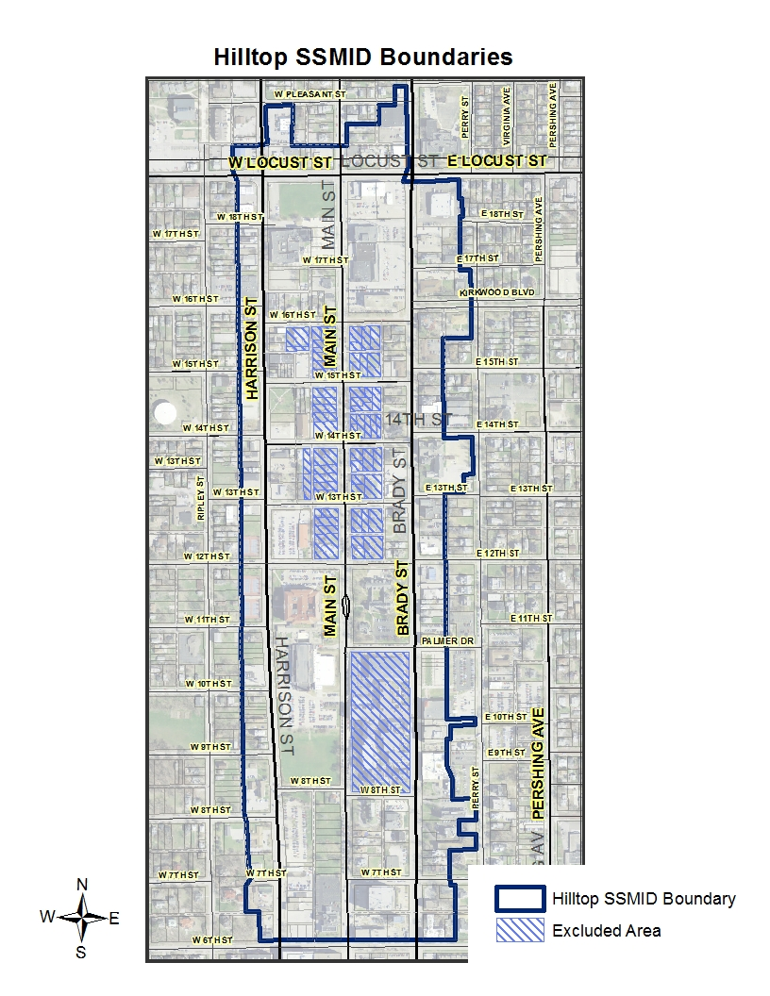
2018 PRoperty IMprovement Program

Application Process

1) Decide what eligible improvements you want to make. If you have questions about eligibility, please contact either KellyLynn28@gmail.com (630-205-3971) or hcvscott@gmail.com, 563-370-2098
2) Complete an application. Your application must include detailed plans and cost estimates for all work to be performed. You must also include photos of the property and the specific area(s) where work will be performed.
3) Return your completed application (including plans, estimates, and color or digital photos) to
Garlisch Financial Group, 2004 Brady Street, Davenport, Ia 52803, 563-322-0800

4) DO NOT order material, sign a contract, or begin work on your project until you receive written approval of your application from the Hilltop Business Association Board; Doing so may make you INELIGIBLE for the rebate.
5) When your project is fully complete (for the entire property), submit all paid invoices, receipts and other required documents for the project. You will receive a rebate check after inspection approval(s). Your must submit color or digital photos of the project area after it is completed as part of the inspection process. Approval is at the discretion of the board.
6) The board will approve PRIMP apps at board meetings on the second Tuesday of each month only. There are no approvals via email.

QUESTIONS AND APPLICATIONS
For additional information and applications, please call one of the following PRIMP Committee members:
Kelly Wallace 630-205-3971 or Scott Tunnicliff 563-370-2098
Website www.hilltopbusinessassociationdavenport.com

Policies and Procedures

The following outlines the minimum data required in order to properly process the rebate once the work is completed.
- All rules in the Informational flyer apply. The Hilltop Business Association Board makes the final decision if ambiguous.

- All Projects must be completed within 9 months, and invoices submitted within 12 months, of application approval.

- If all criteria are met, rebate checks will be processed for all work completed and invoiced, at the next scheduled board meeting.

- Along with the invoices & the certification, photographs showing the completed work at the property are required.

- Detailed copies of the final invoices are required in order to ensure the work done actually qualifies for the PRIMP rebate. If the applicant is having work done other than the exterior improvements approved per the project description, please make sure the invoices submitted are sufficiently detailed so that we may properly process your rebate.

- Under no circumstances will we issue a rebate check over and above the amount approved by the board.

- Checks will be cut by the last day of each month for any invoice received prior to the 5th day of the same month.

- The Board of Directors has allocated up to $25,000 worth of reimbursements for the PRIMP program this year.

- The Board of Directors will make decisions on eligibility based on the information provided in the application and using criteria the Board feels is most appropriate.

- Changes to PRIMP apps are not allowed. Applicants are allowed to withdraw a PRIMP app and resubmit with changes if the work has not started. The resubmitted application must follow all criteria as a new PRIMP

- The project should meet the approval of the Hilltop Business Association and the City of Davenport Design Review Board (if required). Check with DRB to determine if project is required to go before the boards. Contact is Matt Flynn, Senior Planning Manager, City of Davenport, 563 888 2286, matt.flynn@ci.davenport.ia.us.

The Hilltop Association is very pleased to make this program available. They ask for your cooperation in conforming to the rules set forth by the Board of Directors.
Thank you for helping to improve our community.

Certification Letter
( Please keep this letter until the project is finished)

I, _______________________________________ have submitted a Hilltop SSMID
PRIMP application and request that I receive my rebate for the project. I certify the following have been done:

- The project has been completed as applied for in the PRIMP app. If there is any deviation for the original PRIMP app, I have listed the items below. These changes could affect my final rebate amount and must be approved by the Hilltop SSMID Board. Exceptions:

- I have paid the contractor in full for the work completed per the PRIMP application.

- I have not received any rebate from the contractor for this project or in conjunction with other projects.

- I have included after pictures and paid invoices or a copy of the check paid to the contractor.

PRIMP Applicant
Signed ____________________________________ Date ____________

Contractor signature
Signed _____________________________________ Date ____________

Signed _____________________________________ Date ____________

Signed _____________________________________ Date ____________

